Quiz 1 ***(CSE331L.7 – Asif Ahmed Neloy_Summer’20)***

Department of Electrical and Computer Engineering

School of Engineering and Physical Sciences

North South University, Bashundhara, Dhaka-1229, Bangladesh

*Time 20 minutes, Marks 20 (You need to answer all questions).*

***Name –Hosne Ara***

***ID -1632267642***

1. **Why it is never a good idea to store any data in the segment registers?[5]**

**Because segment registers have a special purpose pointing at accessible blocks of memory.**

1. **Write a program in Assembly language that will add 4 integer number (1,2,2,1) using only AX register and Store the result in the AX register.**

**org 100h**

**MOV AX, 01**

**MOV BX, 02**

**MOV CX, 02**

**MOV DX, 01**

**ADD AX,BX,CX,DX ;AX= AX+BX+CX+DX**

**ret**

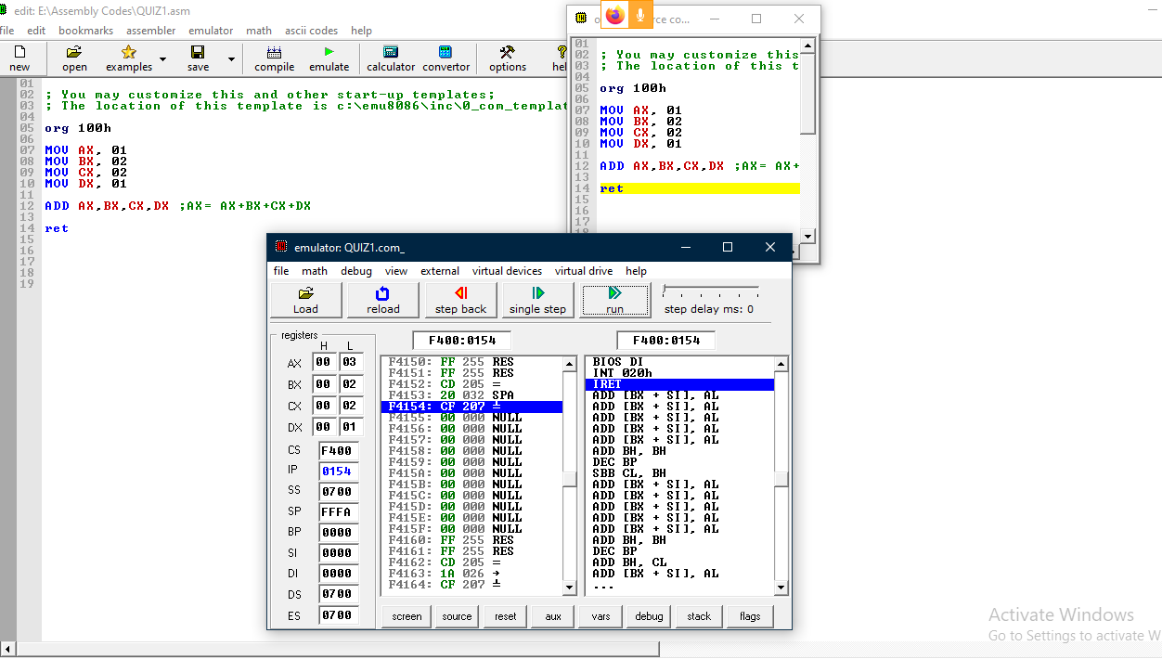

**End**